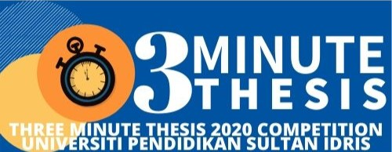

THREE MINUTE THESIS 2020 COMPETITION IMPORTANT DATE

Open for registration
Date: 03th March 2020

Last date for nomination from faculty/ department
Date: 07th April 2020

Last date for registration
Date: 10th April 2020

Training for 3MT contestant
Date: 14th April 2020
Time: 8.00
Venue: Bilik Latihan Utama, Aras Bawah, Blok C, IPS

Last date for 3MT slide submission
Date: 17th April 2020

REHEARSAL DAY
Date: 20th April 2020
Time: 2.00 ptg
Venue: Bilik Latihan Utama, Aras Bawah, Blok C, IPS

THREE MINUTE THESIS 2020 COMPETITION
Date: 21st April 2020
Time: 8.00
Venue: Bilik Latihan Utama, Aras Bawah, Blok C, IPS

